**Introduction and creating image file**

**Objective**

1. To Create tiff and jpeg “image files” using “image operation 1”
2. View it in QGIS

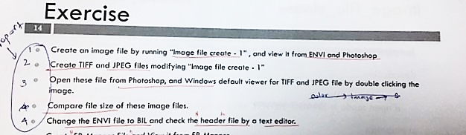

**Code Descriptions**

//Define functions image.c and image.h for handling images on memory and some image functions which are in library which link by “image.h” and “imgio.h” for handling file I/O*/

#include<stdio.h>

#include<math.h>

#include "image.h"

#include "imgio.h"

//Define width, height and channel parameter value

#define W 256

#define H 256

#define NCHAN 3

//Function statement for image set up of new image , ***pix is a variable and it is the pointer to pointer , which point to unsigned character.

void img_setup(u_char ***pix, int w, int h, int nchan);

//Main function part

void main(void)

{

//declare variable, input image is pointing to the img (*img), image file pointing to imgf(*imgf); image file default interleave is set to BSQ format to save the file.

IMAGE *img;

IMAGE_FILE *imgf;

image_file_default_interleave_set(IMAGE_BSQ);

//Calling allocate memory for image function, the pixel type is character. Four Variable are w,h, pixel and nchannel. If image allocation is null, exit the program.

printf("calling:image_alloc\n");

if ((img = image_alloc(W, H, IMAGE_CHAR, NCHAN)) == NULL){

fprintf(stderr, "image allocation error\n");

exit(1);

}

//Calling set up new image function with 4 properties such as w,h, n data and number of channel. Img>w 1024 and img>h 1024.

printf("calling:image_setup\n");

img_setup(img->data, img->w, img->h, img->nchan);

//Calling create image function , output image name is “color”. Image_trunc is using to remove digits after decimal point and return the modified decimal number. If file create error exist the program.

printf("calling:image_file_create\n");

if ((imgf = image_file_create("color.img", IMAGE_TRUNC, 0, img)) == NULL){

printf("image_file_create_error\n");

exit(1);

}

/*And then this part for create JPEG image file type. Automiatic file type is img but now create Jpeg (.jpg) If file create error exist the program. */

/* if ((imgf = image_file_create("colorJPEG.jpg", IMAGE_TRUNC, 0, img))

== NULL) {

printf("image_file_create error\n");

exit(1); }*/

//Calling close image file function

printf("calling:image_file_close\n");

image_file_close(imgf);

//Calling destroy image file function

printf("calling:image_destroy\n");

image_destroy(img);

}

/*Function image file set up for set up output image, get the values for w,h, nchan and pixels*/

#define PI 3.14159265

void img_setup(u_char ***pix, int w, int h, int nchan)

{

int i, j, ichan;

for (ichan = 0; ichan < nchan; ichan++){

printf("img_setup:channel %d\n", ichan);

for (i = 0; i < h; i++)

for (j = 0; j < w; j++)

pix[ichan][i][j] = sin((double)j / (w*(1 + ichan*0.5)) * 2 *

PI*(10.0*i / h)) * 127 + 128;

}

}

**Output**

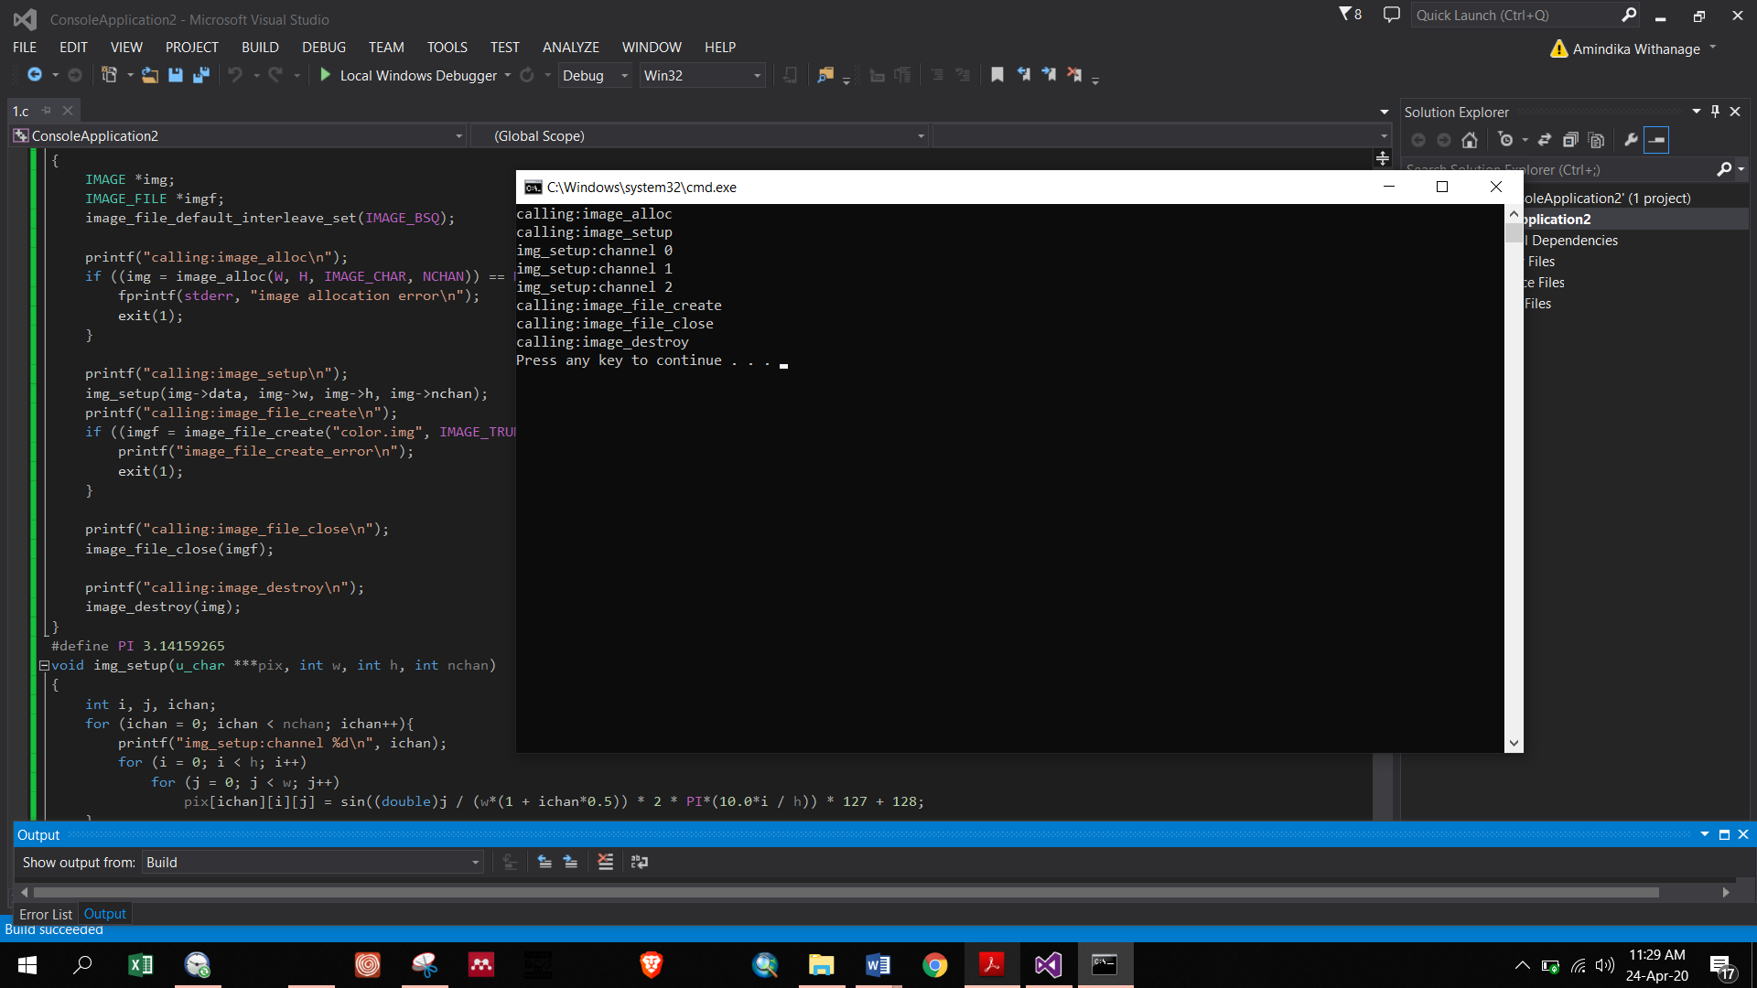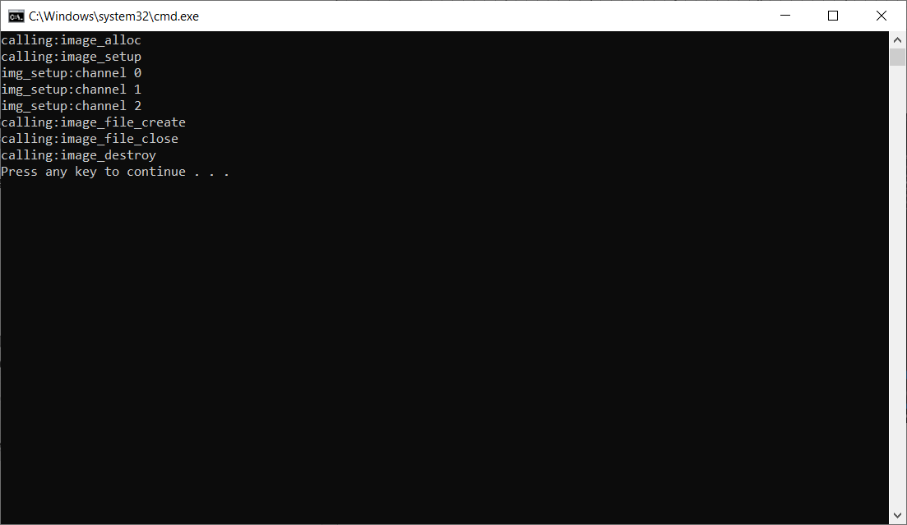

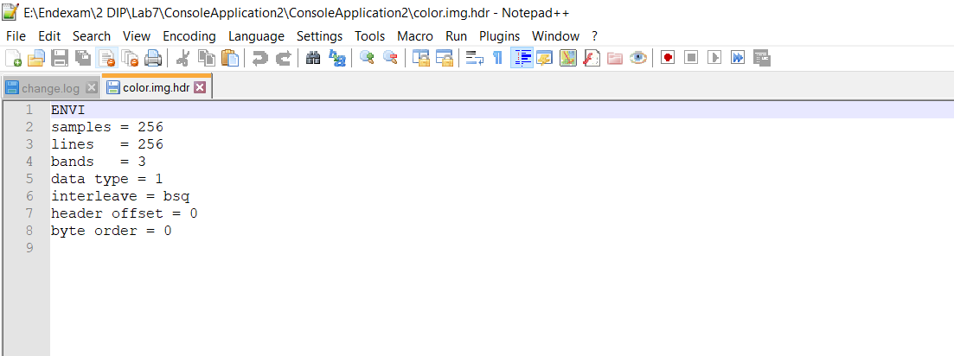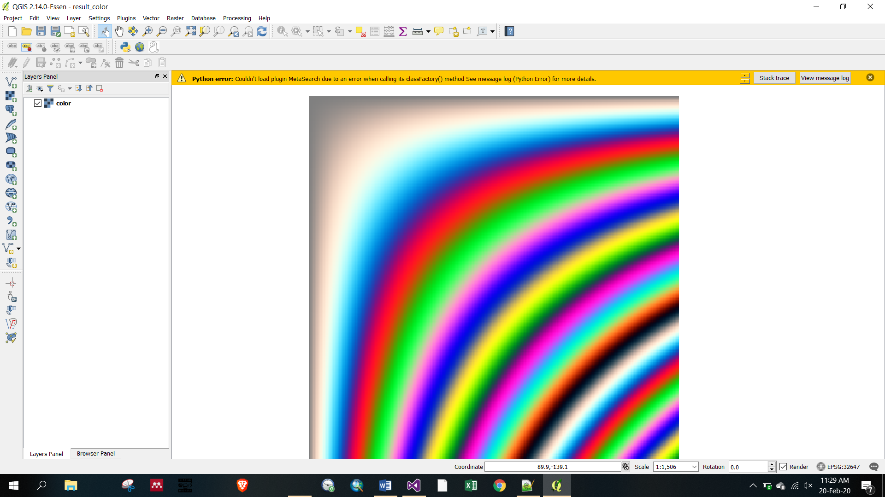

**Figure 1:** Jpeg output image type is opened in QGIS

Tiff need more size allocation than .jpg format. Quality of Jpeg is not good due to compression. Tiff image quality is high than jpeg.